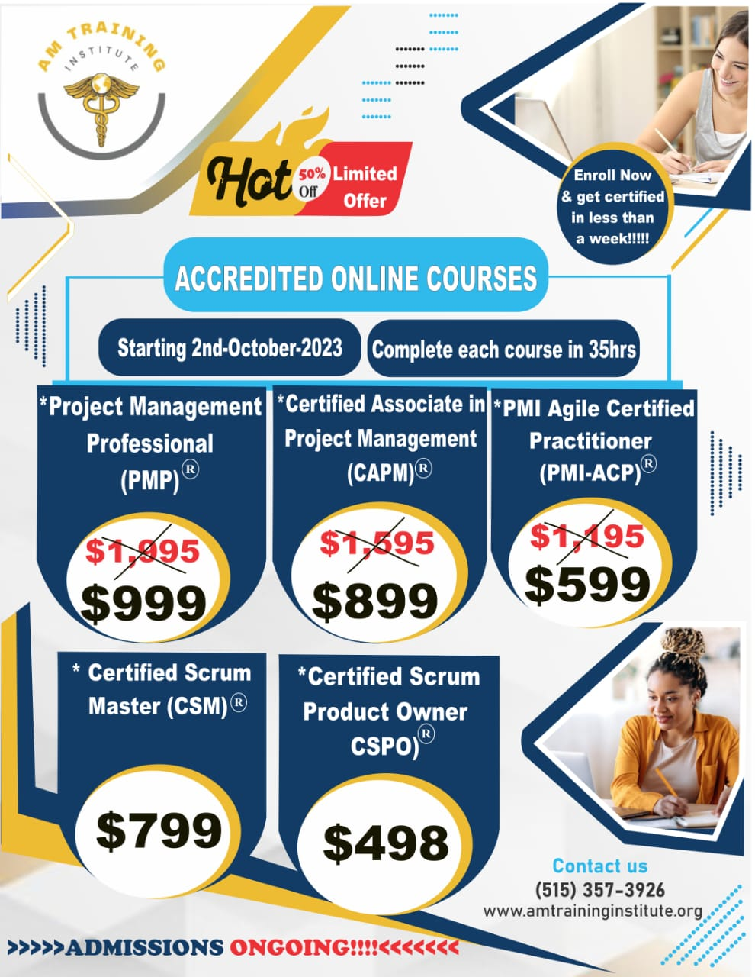
(image for reference only)

Project Management Courses

Enroll now and get certified in a week.

Accredited Online Courses
Starting 2nd October 2023
Complete each course in 35 hrs

Project Management Professional (PMP)
- Mastering Project Management: Introduction to Project Management concepts and approaches
- Managing Multiple Tasks, Priorities & Deadlines
- Project Planning, Scheduling & Control: Global Best Practices
- Learn important aspects of leading a project team to achieve a successful project
- Measuring performance at every stage, master how to lead a seamless project
- Closing the project, obtaining acceptance of the project deliverables, Documentation, formalize closure and handing over
- PMP Exam Preparation: Exam Strategy Guide, Mock PMP Exams
Fees: $1,195 $599

PMI Agile Certified Practicioner (PMI-ACP)
Become a skilled Agile Practitioner. Enhance and validate your knowledge of Agile practices and techniques with the PMI-ACP® certification.
- Practice latest Agile principles and techniques
- Learn principles and practices of agile, including Scrum, XP and Lean
- Immersive course, designed by experienced Agilists
- Experiential learning, real-world simulations, case studies and more
- Digital PMI-ACP exam prep materials, training aids, online resources, realistic sample questions will be provided
Fees: $1,995 $999

Certified Associate in Project Management (CAPM)
Distinguish yourself in a competitive job market as a new graduate with CAPM Certification
Learn the fundamentals and terminologies of project management
CAPM enables you to pursue the PMP Training without the 3+ years work experience needed for PMP
develop growing levels of competence in the practice of project management
Fees: $1,595 $899

Certified Scrum Product Owner (CSPO)
Introduction to theory, values, rules, roles, events and artifacts of Scrum
Be part of the world's largest Agile community
Get comprehensive exam support including Mock Tests
Get trained by globally renowned Certified Scrum Trainers
Simplified deep learning
Fees: $498

Certified Scrum Master (CSM)
Be part of the world's largest Agile community
Get trained by globally renowned Certified Scrum Trainers
Simplified deep learning
Understand how to engage with a Product Owner in value-based conversations
Fees: $799

GUARANTEED JOB OPPORTUNITIES
- IT Project Manager
- IT Project Manager & Scrum

Admissions Ongoing
Payment Options and Affordable Payment Plans Available
Contact us for more information

